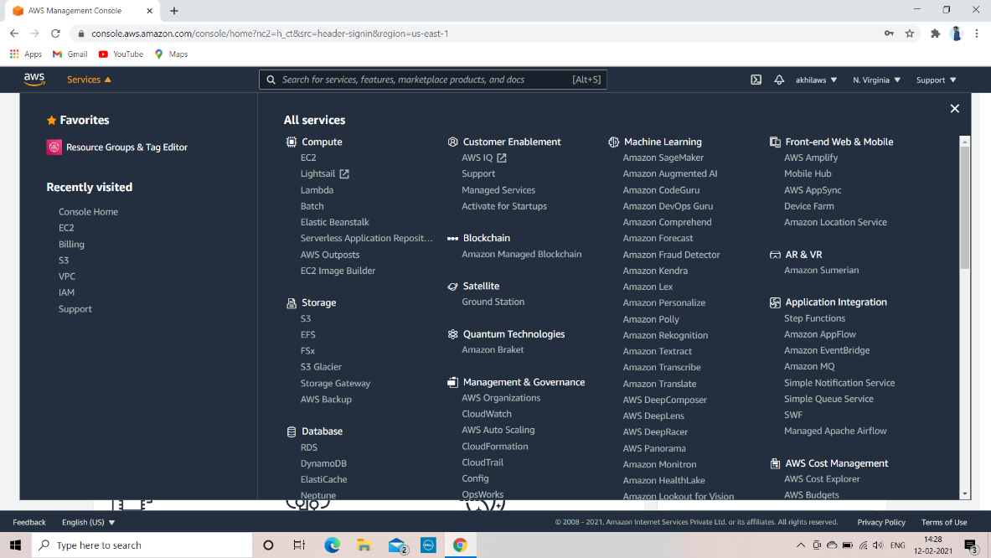

open aws console and log in and go to aws services

1. Select Ec2 services and go to instancesd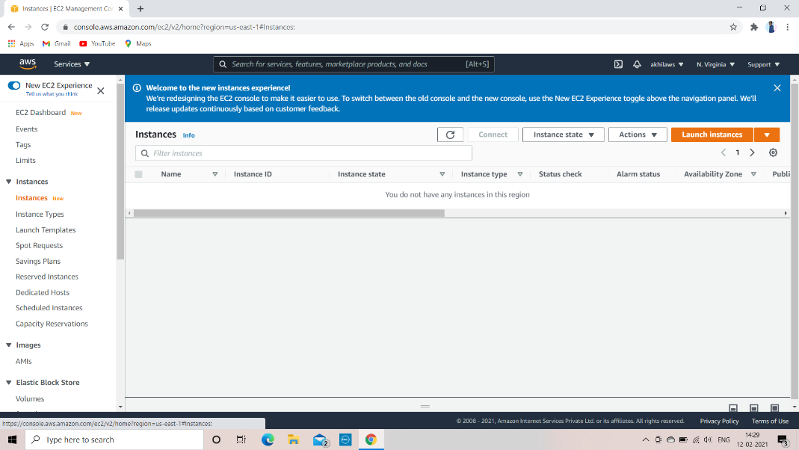

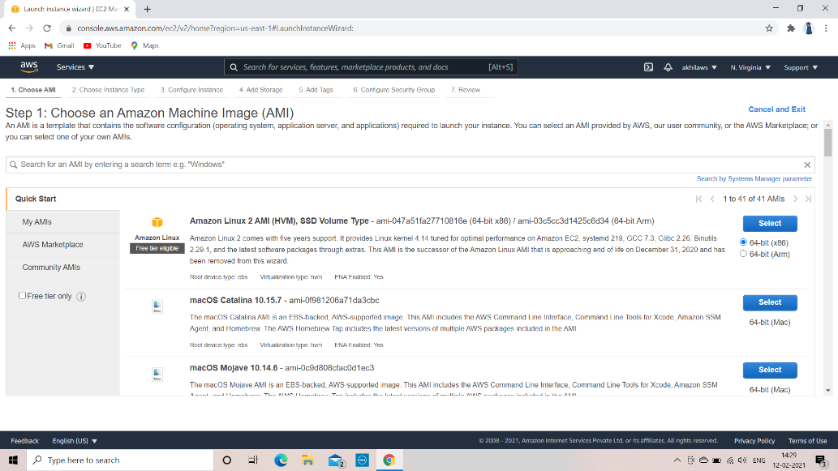

Select AMI which you want to launch

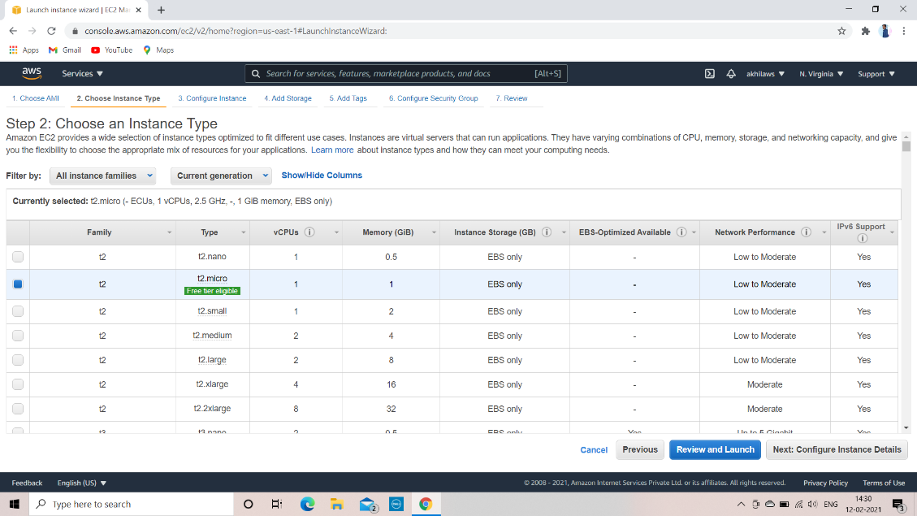

Select instant type which is free tier eligible

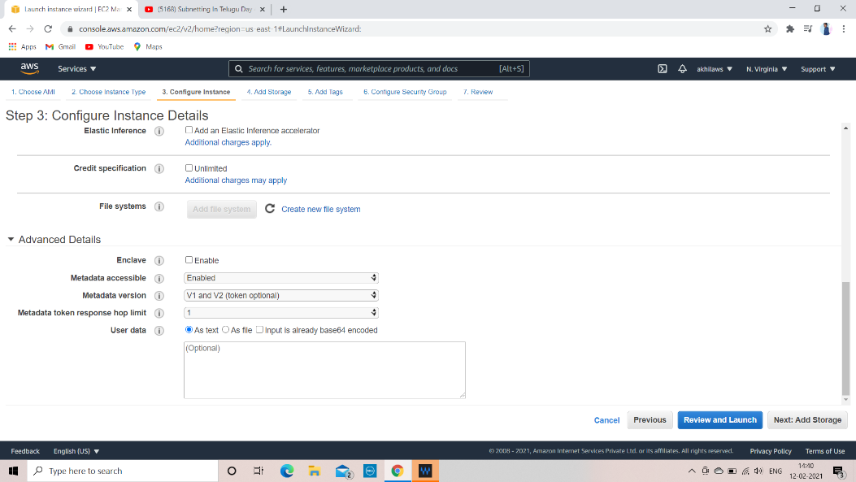

Configuration instance number instance you launch and region

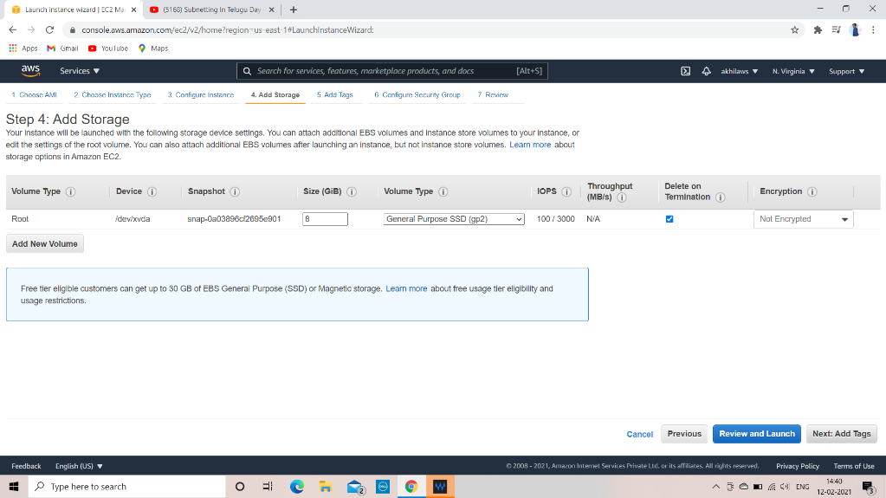

Add storage

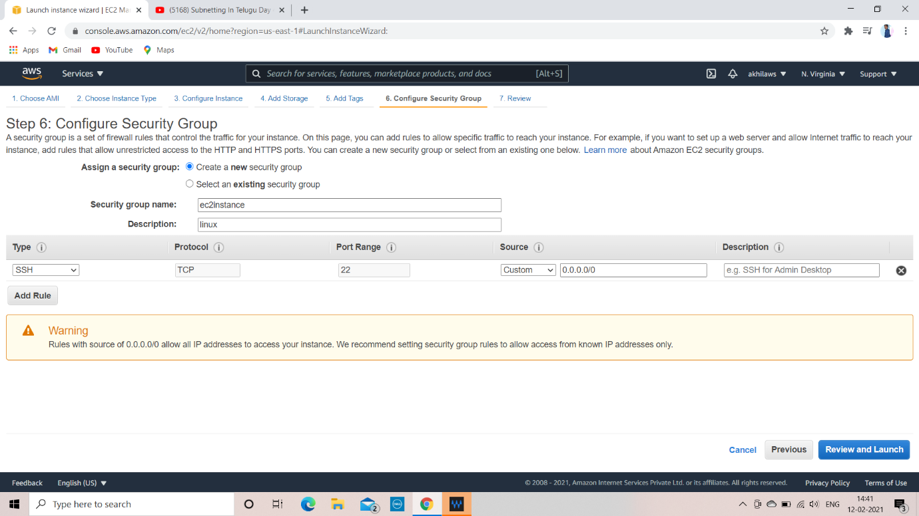

Configure security group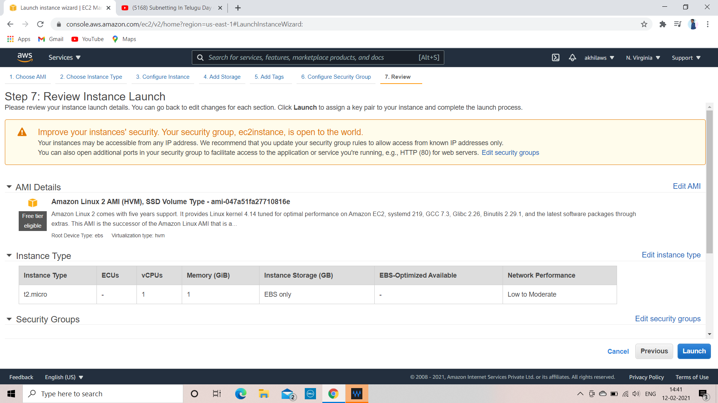

Revisew and lauch

Use existing pemkey or create new pem

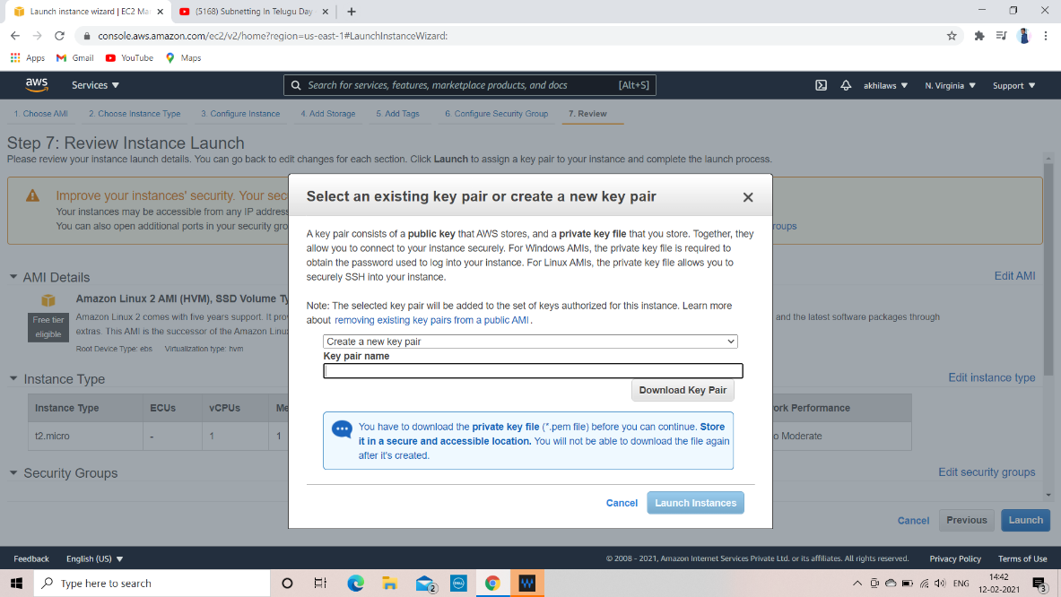

To connect ec2 instance to linux open winscp and using winscp copy pem key to linux

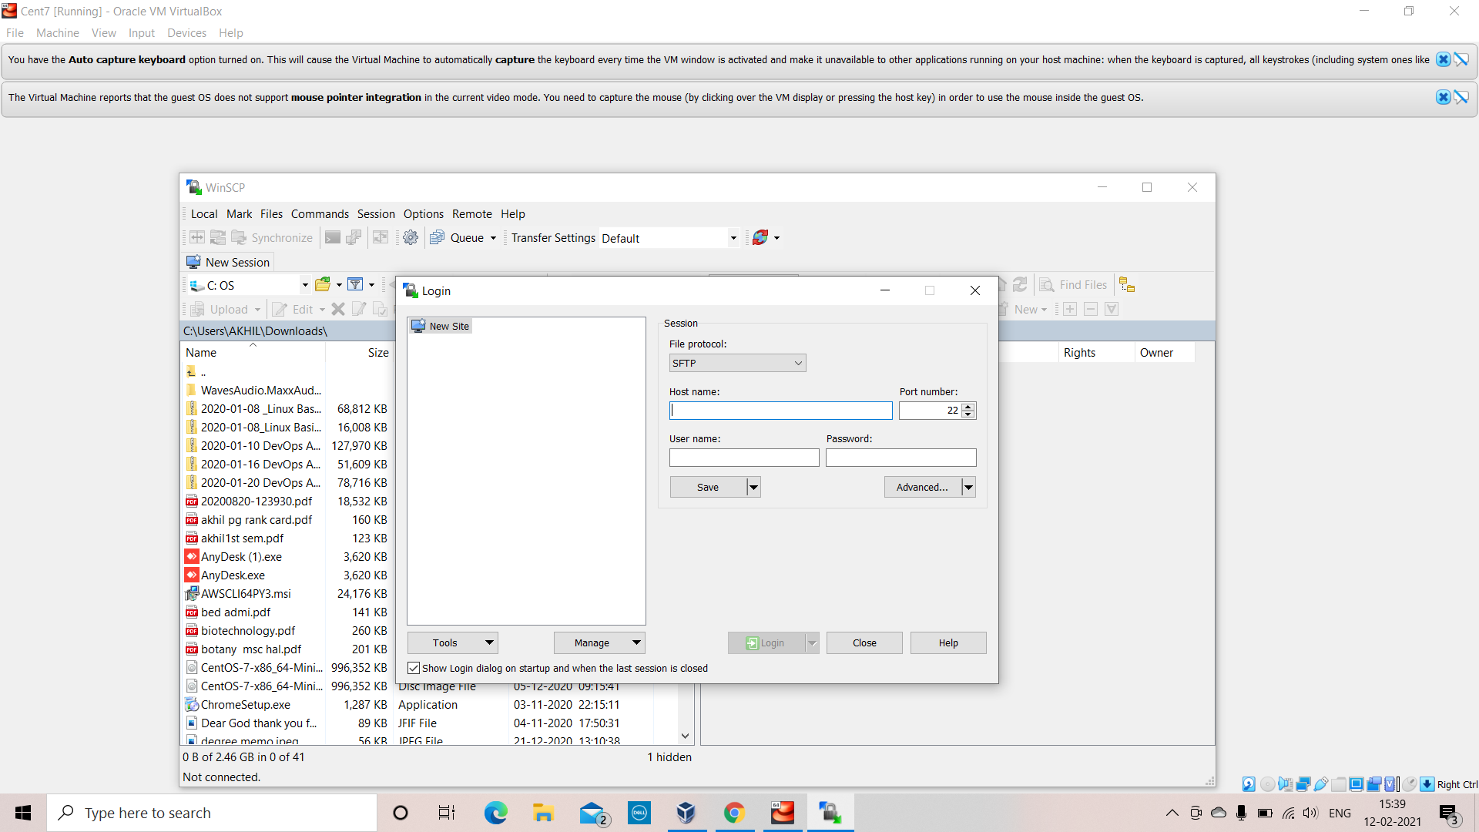

And change the permission using chmod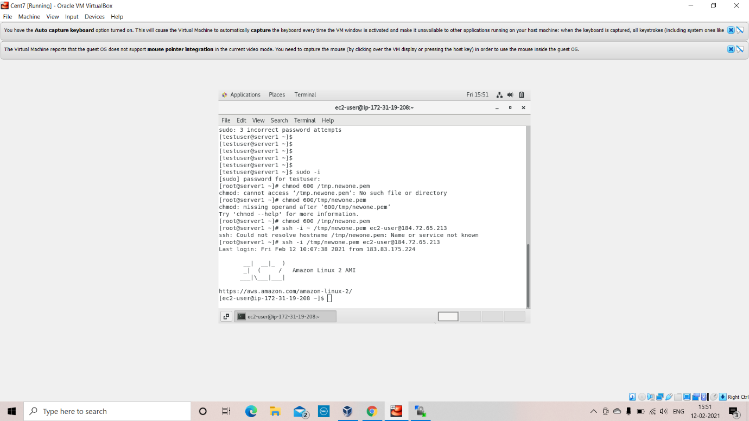

To connect ec2 instance to windows

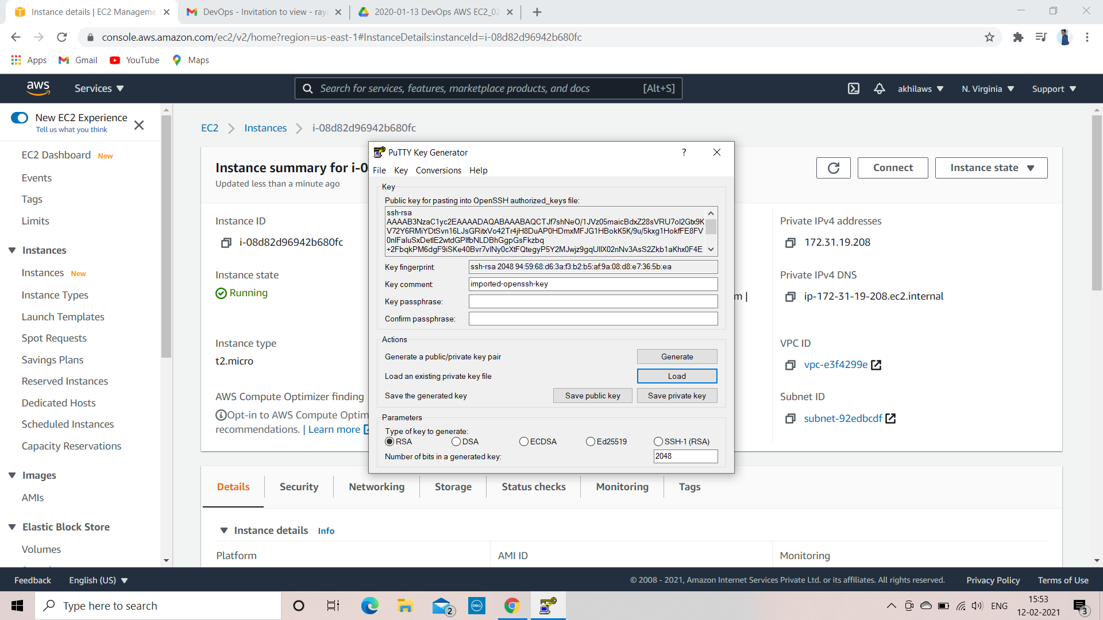

To connect to ec2 instance to window . we cannot connect ec2 directly first we will convert pem to ppk by using putty gen load pem and saves as private key

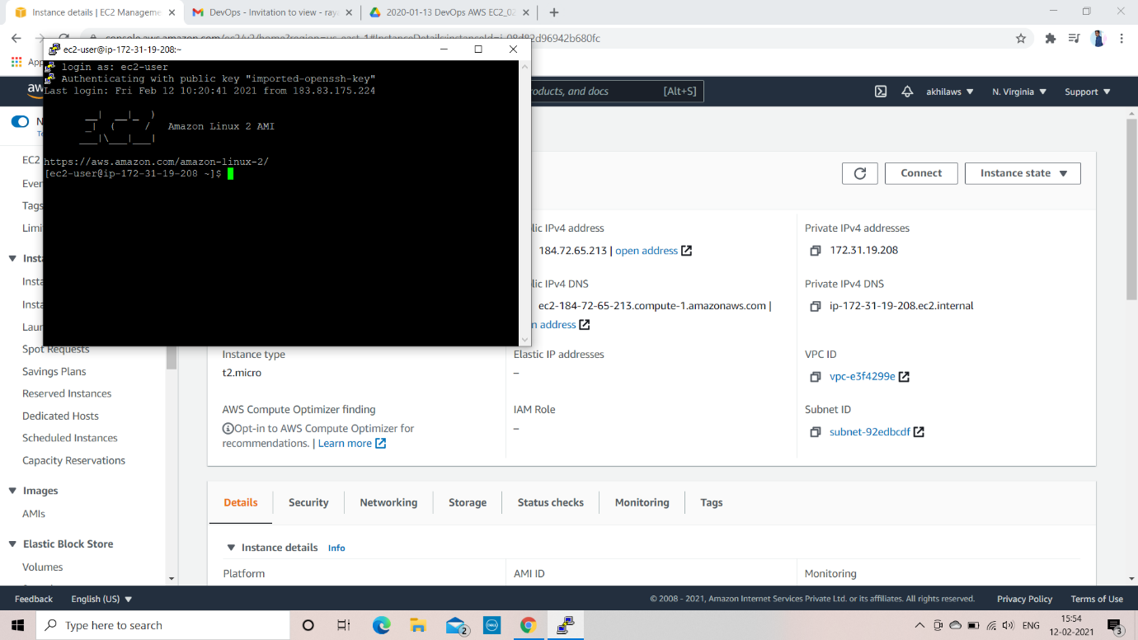

Enter ec2 instance public ip address in putty as host ip and select ssh and auth and connect ec2 instance to putty